**CURRICULUM VITAE**

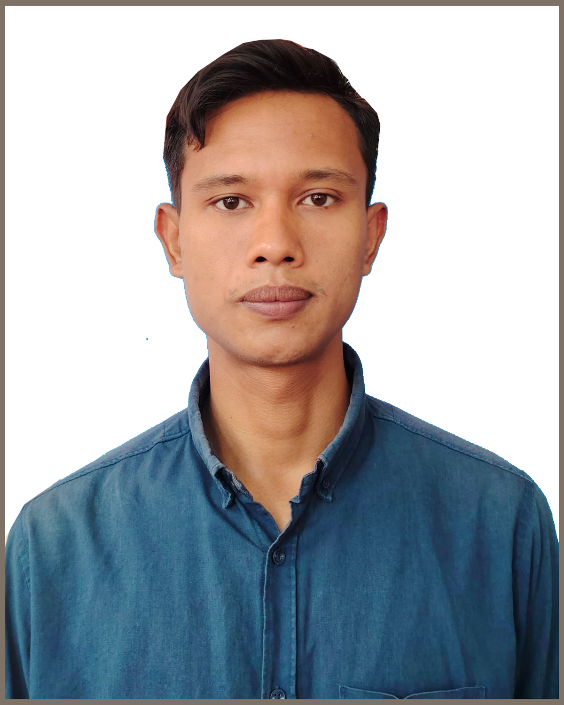

**Name : SAJIB CHANDRA RAY**

**Contact No :** 01568087179

**E- Mail : roysajib249@gmail.com  
Address : Aditmari, Lalmonirhat.**

###### CAREER OBJECTIVE

Looking for a dynamic and challenging job to utilize my background and willing to work in a creative and technical environment where there are scope to utilize knowledge and creativity. Skill, expertise and confidence with heartiest sincerity that ultimately run to execute the job responsibilities.

**EDUCATIONAL ATTAINMENT**

* **Examination : Bachelor Degree Honors’ (BBA)**

Institution : Lalmonirhat Govt. College, Lalmonirhat.

Subject : Management

Passing of year : 2022

Result : 2.98 (out of 4)

Board : National University

* **Examination : Higher Secondary Certificate (HSC)**

Institution : Lalmonirhat Govt. College, Lalmonirhat.

Group : Bussiness Studies

Passing of year : 2018

Result : 3.92 (out of 5)

Board : Dinajpur

* **Examination : Secondary School Certificate (SSC)**

Institution : Lalmonirhat Govt. High School, Lalmonirhat.

Group : Bussiness Studies

Passing of year : 2016

Result : 4.44 (out of 5)

Board : Dinajpur

# KEY QUALIFICATION

☼ Good Knowledge on Computer.  
☼ Communication skill both in written and spoken English.

# LANGUAGE PROFICIENCY

**☼** Proficiency in oral & written communication in Bengali & English.

**☼** Strong interpersonal skills.

###### PERSONAL INFORMATION

Father’s Name **:** Ratenashor Barman

Mother’s Name **:** Projapoti Rani

Permanent Address **:** Vill: Purbodoilzor, P.O : Bhelabari-5510,

P.S: Aditmari, Dist: Lalmonirhat. Div: Rangpur.

Present Address **:** Vill: Purbodoilzor, P.O : Bhelabari-5510,

P.S: Aditmari, Dist: Lalmonirhat. Div: Rangpur.

Date of Birth **:** 30 December 1999

NID No. **:** 7356831995

Gender **:** Male.

Blood group  **:** O+ (Ve)

Religion **:** Hinduism.

Marital status **:** Unmarried.

Nationality **:** Bangladeshi by Birth.

Height **:** (5-10)"

Mobile no :01568087179

#### Why Me

☼ Able to work under challenging environment

☼ Sincere and eager to learn

☼ Willing to work in team

☼ Ability to motivate people

☼ Good managerial and leadership skill

**DECLARATION**

I hereby declared that, all the details mentioned above are my own and true to the best of my

Knowledge

Signature

(Sajib Chandra Ray)